Name- Priyanshu Rishi

Reg no- RA1911042010041

Batch- CSBS-R1

Course- software Design with UML

Topic- UPE

**Question-**  Consider the following scenario and Model an activity diagram: The goal is to process different types of credit applications at a bank. The credit applications include those for home equity loans, home mortgage loans, auto loans, and credit cards. From  
the bank’s perspective, therefore, the customers are home owners, home buyers, auto buyers, and credit card applicants. To process any type of loan or credit card application, the bank needs to check the applicant’s credit history, based on a report  
from the credit bureau. For the first two types of loans, the bank summons and assessor to assess the property value before making a decision.  
b. Model a package diagram for an automated teller machine (ATM).

**Aim :-** The aim is to draw an activity diagram for a loan management system and a package diagram for ATM.

**Problem Statement:-**  The problem states to draw an activity diagram for an loan management system from the bankers perspective where if a person apply for loan then the bank needs to check the credit history or the assess the property value before making a decision.  
b. Make a package diagram for an ATM.

**Diagram:-**

1. **Activity Diagram**

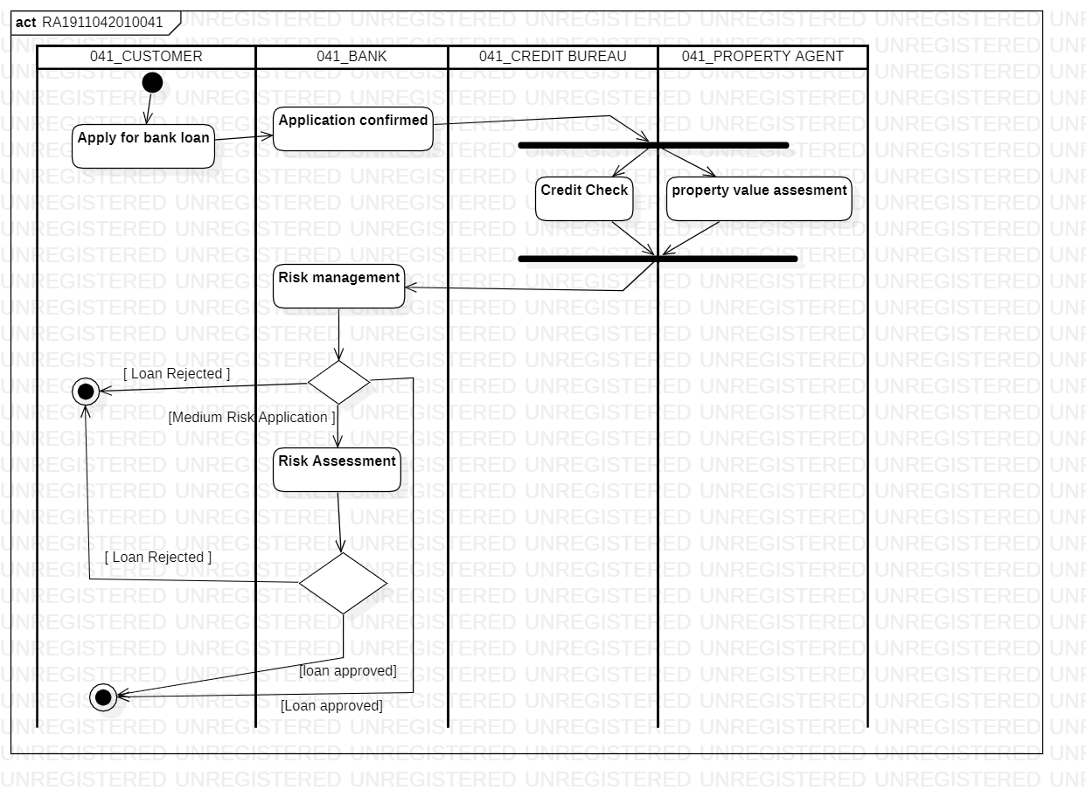

1. **Package Diagram**

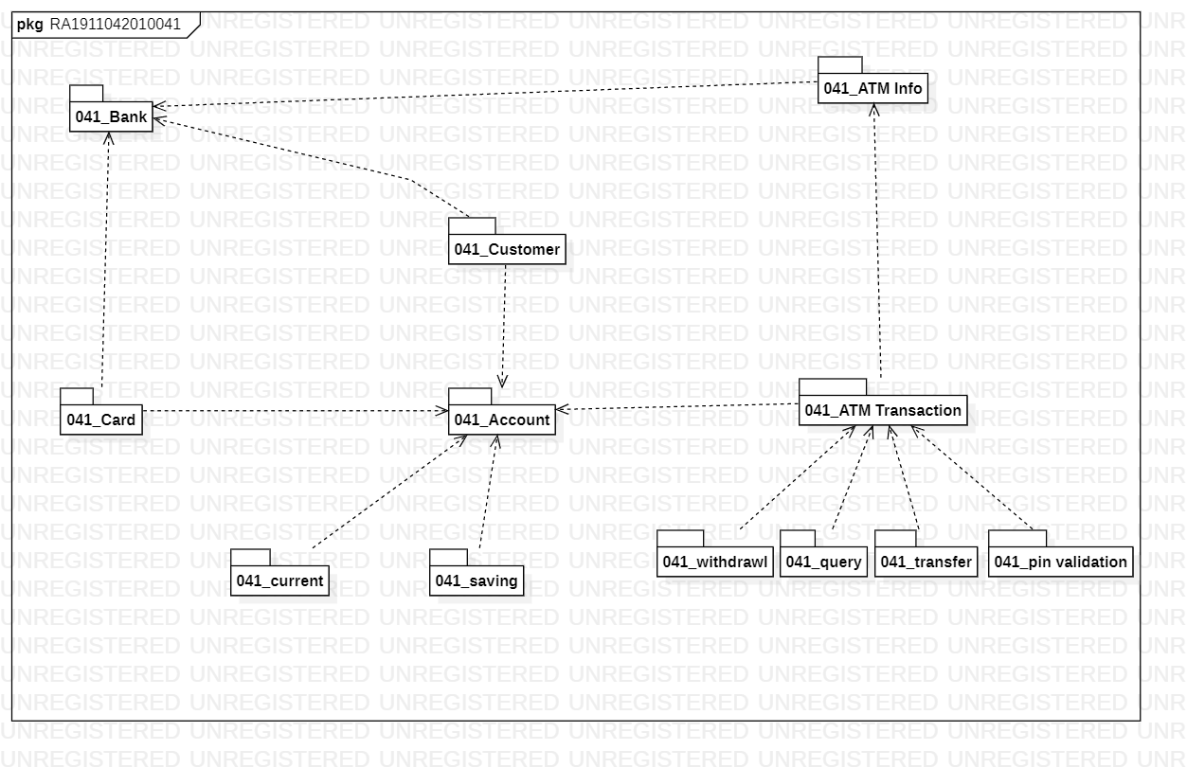

**Result:-** Hence, we have successfully prepared an activity diagram and a package diagram